BLE Multi-Role
- 🧭 Role Switching (Peripheral ↔ Central ↔ Repeater)
- 📡 Periodic Advertising (PA)
- 🔁 Periodic Sync + Data Exchange
- 📥 MAC-Based Acknowledgment & Sync Filtering
- 🔄 Central selection via "best code"

✅ Project Overview: ESP32 BLE Bi-Directional Periodic Advertising Mesh
This project implements a scalable BLE mesh-like architecture using Extended + Periodic Advertising, bi-directional communication, and FreeRTOS task-based design. Devices operate in one of three roles — Central, Repeater, or Peripheral — and communicate without connections using advertising-only PDUs. The goal is to enable:
- 🔄 Data flow from Peripherals to Central
- ✅ ACKs from Central to Repeater and then to Peripheral
- 🔀 Multi-device routing and relay

🧭 Core Architecture

1. 🔁 Bi-Directional Periodic Advertising
- Central and Repeaters transmit & receive Periodic Advertising PDUs.
- Each device advertises data and listens for sync or ACKs.
- This enables two-way data exchange without BLE connections.

2. 📶 Extended + Periodic Advertising (PA)
- Extended ADV (AUX_ADV_IND) used to initiate syncs.
- Periodic ADV (PA) on secondary channels used to send/receive:
  - Sensor Data
  - ACK payloads
  - Role/type/MAC identifiers

3. 🔄 Data Flow
PERIPHERAL → REPEATER → CENTRAL (Sensor data)
CENTRAL → REPEATER → PERIPHERAL (ACKs)
- Peripherals send periodic packets with sensor data(Dummy Data)
- Repeaters collect, forward to Central.(For now Sending Dummy Data , will add this feature when integrate the sensor code)
- Central generates combined ACK for all synced devices.
- ACK sent once via PA

🔀 Role-Based Logic

1. 🎭 Role Derivation
- At boot, each device determines its role based on:
  - Wi-Fi connection (enabled/disabled)
  - Previous sync presence
  - Last received ACK
- Roles:
  - Central: Wi-Fi + no upstream ACKs → collects data, sends ACKs
  - Repeater: No Wi-Fi + seen ACKs → bridges data both ways
  - Peripheral: No Wi-Fi + no ACKs → generates sensor data

2. 🔀 Dynamic Role Switching
- Device roles can switch at boot or via:
  - Sync timeout
  - Event queues
  - ACK reception/loss

📡 Communication Mechanisms

1. 📦 Payload Design
Each advertisement contains:
- Type (e.g., A1C, B2R)
- Numeric Code [1-9 ,corresponding to Type
- MAC[3:6]
- Flags for ACK, SYNC, sensor data(Dummy)

2. 🧪 MAC Filtering
- Devices only respond to expected MACs
- Ensures correct sync targets and ACKs

3. 🔢 SID Calculation
- SID = XOR(mac[0..5]) & 0x0F
- Each advertiser has a unique SID
- Used to manage syncs and match advertisements

🔁 Combined ACK Mechanism
- Central receives data from Multiple Repeater / Peripherals
- Builds one ACK with all valid MACs or last 3 bytes
- Sends ACK in Periodic ADV
- Repeaters decode it

✅ Actually Use:
- Common tasks and queues/semaphores shared across roles
- Role-specific logic is triggered inside shared handlers and tasks:
  - BLE GAP event handler: gap_event_handler() dispatches to:
    - gap_event_handler_Central()
    - gap_event_handler_Repeater()
    - gap_event_handler_Peripheral()
  - One GAP handler is registered at runtime, switching based on my_current_role.

✅ Event-Driven Design:
- xTaskNotify() and xQueueSend() to trigger logic based on:
  - ESP_GAP_BLE_PERIODIC_ADV_REPORT_EVT
  - ESP_GAP_BLE_EXT_ADV_REPORT_EVT
  - Other GAP events
- Synchronization via:
  - SemaphoreHandle_t test_sem
  - QueueHandle_t Scanning_Queue, syncQueue
  - Flags like new_data, sync_stage, is_synced

✅ Role Separation:
- Each C file (central.c, repeater.c, peripheral.c) implements:
  - Its own version of GAP event handlers
  - Functions for extended/periodic advertising setup
  - Response to sync/ACK messages
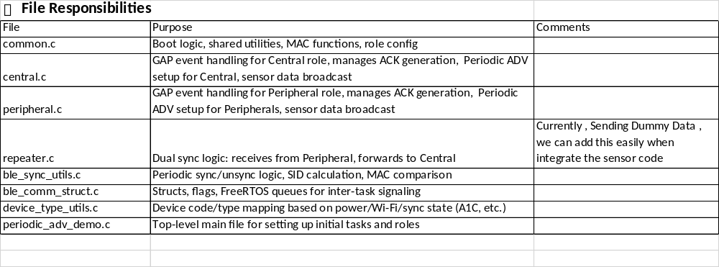
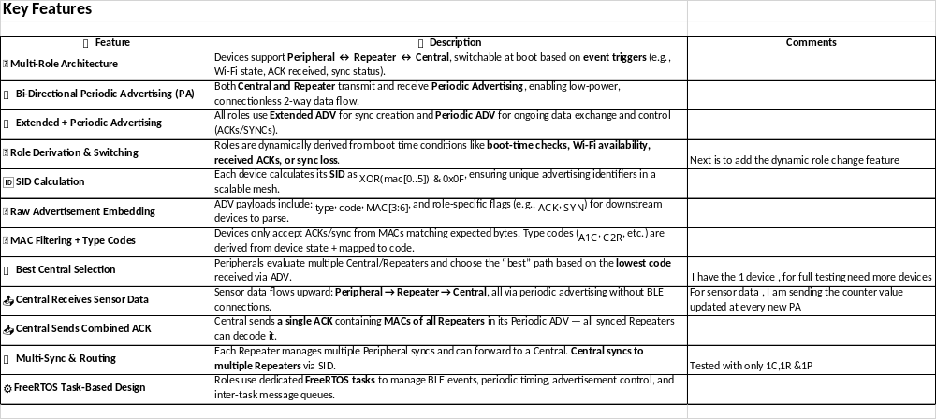

Test Results:

Central:
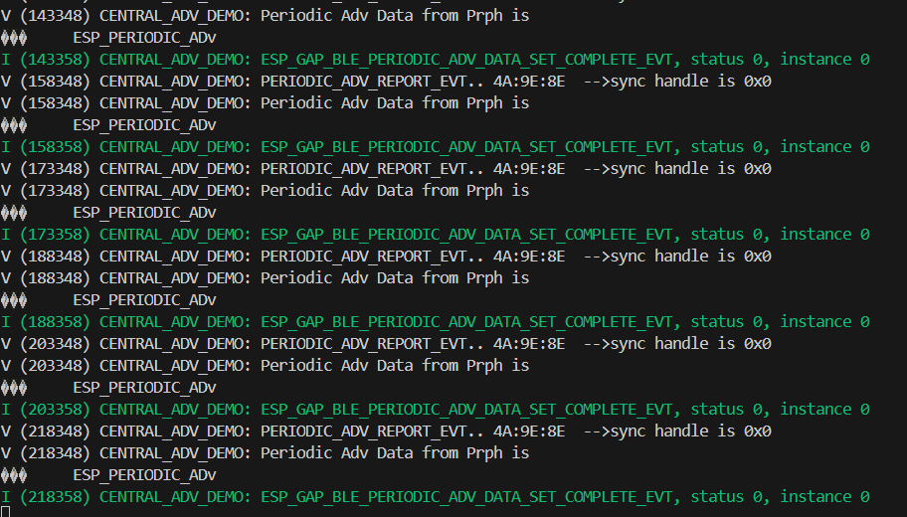

Repeater :
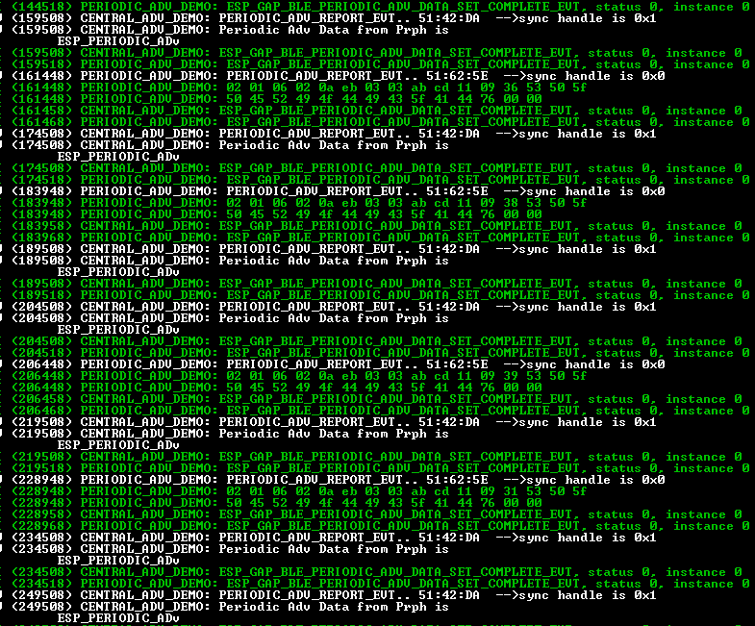

Peripheral:
